The Action Steps for Complete Change Plan
Student’s Name
Institutional Affiliations

The Action Steps for Complete Change Plan
Introduction
Organizational change is inevitable, but sometimes, it is difficult to realize due to the obstacles that emanate within and outside the company. Every organization initiates change for good reasons; for instance, to help them improve performance, enhance customer services, solve customer related problems, create new revenue channels, reduce the costs of operations and many other. Change helps the organization solve its problems. The following is the change plan for overcoming change resistance in Terra Nova.
The Action Steps
Based on Kotter’s eight-step change model, I would recommend that Terra Nova implement the following steps in overcoming the change resistance in the organization.
Step 1: Create Urgency
For change to take place, it is important that the whole company desires it. This is the first step in Kotter’s 8-step change model, which emphasizes the need to develop some sense of urgency for the desired change. In this case, the management or the director needs to become committed to convincing the other members, especially employees that there is a need for change. The other key players like employees are responsible for implementing the change. As shown in the AIDA chart below, the management must attract the attention of the other stakeholders in accepting the change.
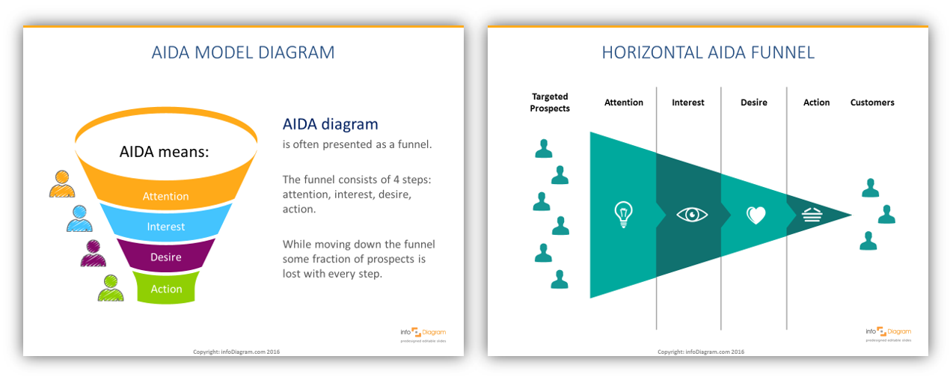Figure 1: AIDA Chart (Source: Google.com)
Step 2: Form a powerful coalition
In this step, the company will be required to convince other stakeholders like employees, investors, and the community where it operates that change is necessary. Change resistance can come from within the organization, especially among employees, or outside. From the above figure showing AIDA chart, interest and desire are some the key components that must be taken into consideration while implementing change. The stakeholders must feel the need to take part in the change so that they can give it their full support.
Step 3: Create a vision for change
Like the previous stage, this step ensures that everyone gets to understand the idea behind the change and how it will help them improve their performance. It is in this step that the company will need to create a strategy to implement the change. For Terra Nova, resistance to change can be eliminated by helping the employees understand how the change will help them to better their performance.
Step 4: Communicate the vision
In AIDA’s chart, the desired level shows that all stakeholders must be engaged to enable them to feel interested in the change. Based on Kotter’s 8-step change model, communicating the vision for change to all the stakeholders is one way to realize its successful implementation. Resistance to change in Terra Nova mainly emerges internally. Therefore, communication with employees will help them understand that the change is for their benefit.
Step 5: Remove obstacles
Removing the obstacle is the main purpose of this change plan. The obstacle is resistance to change, especially among employees who may feel that because it has been long since the change occurred, there would be no need to change.
Step 6: Create short-term wins
It is believed that nothing can motivate people more than success. To give Terra Nova taste of victory early, the management will have to create some short-term gains that the employees can see. This can include creating projects and dividing responsibilities among the employees so that they can see the benefits of such a change. Instead of working on the same project that could take longer to achieve, the management can divide employees into smaller groups to manage simple and short-term projects as shown in the following responsibility chart.
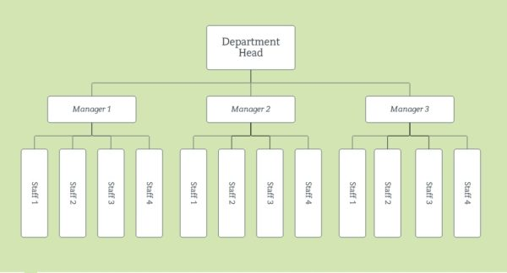
Figure 2: Responsibility Chart (Source: Google.com)
Step 7: Build Change
Based on Kotter’s model, change runs deep in the organization. In this case, the company can set goals to enable them continue building on the momentum that they have achieved.
Step 8-Anchor the Changes
Any change occurs to stay and stick to the organization. Like in the case of Terra Nova, if resistance to change is eliminated, it should stay that way. This can be achieved through talking about progress every time in the organization.
Responsibility Charting
Actions or Decisions | Head of Department | Manager of Project 1 | Manager of Project 2 | Manager of Project 3
Creating urgency | R | A | R | A
Form powerful coalition | I | A | R | A
Create a vision | I | R | S | I
Communicate vision | S | R | S | R
Remove obstacles | A | S | I | S
Create short-term win | I | I | A | S
Build change | I | I | I | R
Anchor the change | A | I | I | I
Table 1: Responsibility Charting Matrix
Coding:
R = Responsibility (not necessarily authority)
A = Approval (right to veto)
S = Support (put resources toward)
I = Inform (to be consulted before action)
References
Mind Tools. (2018). Kotter’s 8-Step Change Model. Mind Tool. Retrieved from https://www.mindtools.com/pages/article/newPPM_82.htm

